STAGE 5- EXPERIENCE MAP

(JOURNEY MAP/CUSTOMER EXPERIENCE)

Journey map is a path where a user navigates through the entire application. It traverses from how the user would find our application and its journey while going through our app features. The users thinking and feeling while using a feature is also taken into consideration.

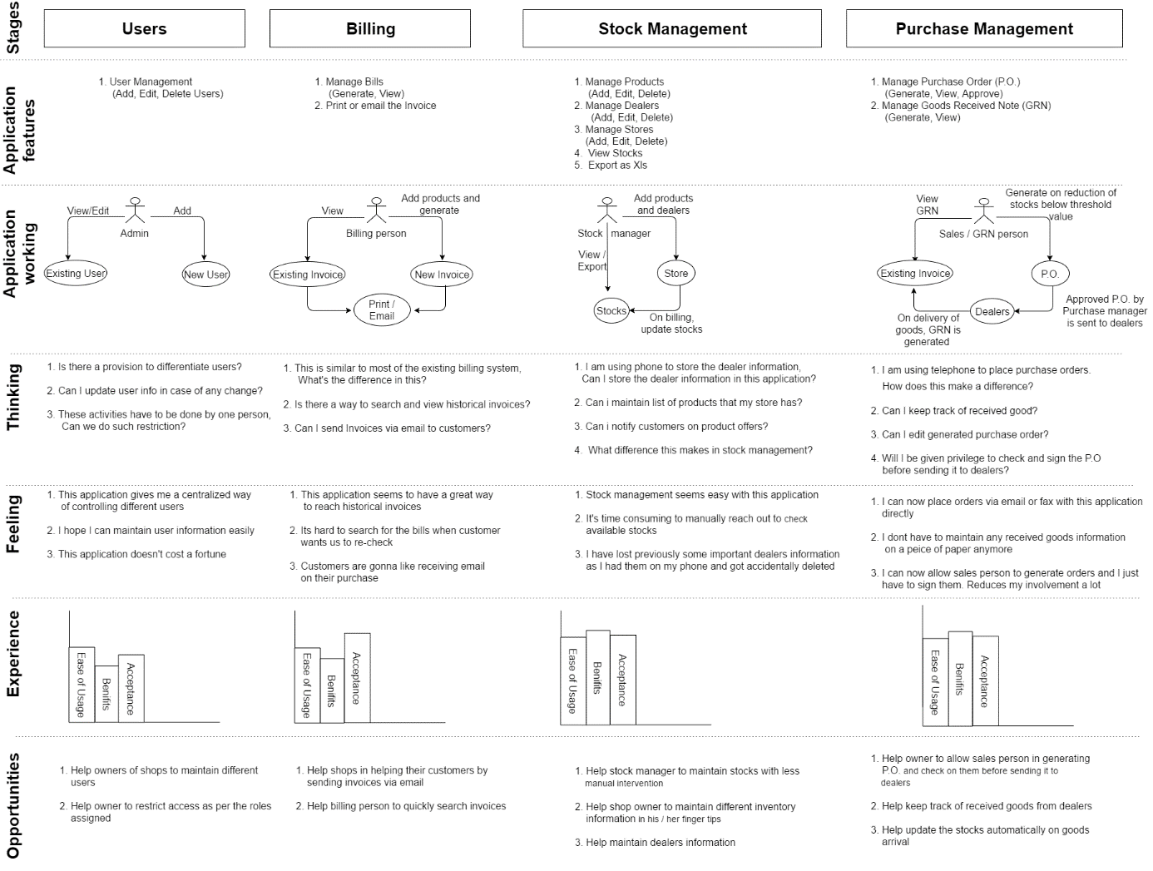

Stage 1: Users

Features: User Management

*Application working:*

The owner of the shop should keep track of employees of his stores. He/she should have all the information about his employees and it should be safe and accessible to designated persons. Also, this information should be easily editable in case of any changes in the employee information such as change in address, phone number etc.

*Thinking: Owner’s thoughts when he thinks of an application*

1. Is there a provision to differentiate users?

2. Can I update user info in case of any change?

3. These activities must be done by one person; can we do such restriction?

*Feeling: Owner’s feelings towards application*

1. This application gives me a centralized way of controlling different users.

2. I hope I can maintain user information easily.

3. This application doesn't cost a fortune.

*Opportunities:*

1. Help owners of shops to maintain different users.

2. Help owner to restrict access as per the roles assigned.

Stage 2: Billing

Features:

1. Manage Bills (Generate, View)

2. Print or email the Invoice

*Application working:*

Billing person expects a straightforward way to search for an invoice that was generated in the past. Also, expects newer way of helping the customers not lose the invoices generated. The application allows user to view the historical invoices by searching with different filters and emailing the invoices to the customers.

*Thinking: Owner’s thoughts when he thinks of an application*

1. This is like most of the existing billing system, What's the difference in this?

2. Is there a way to search and view historical invoices?

3. Can I send Invoices via email to customers?

*Feeling: Owner’s feelings towards application*

1. This application seems to have a great way to reach historical invoices.

2. It’s hard to search for the bills when customer wants us to re-check.

3. Customers are going to like receiving email on their purchase.

*Opportunities:*

1. Help shops in helping their customers by sending invoices via email.

2. Help billing person to quickly search invoices.

Stage 3: Stock Management

Features:

1. Manage Products (Add, Edit, Delete)

2. Manage Dealers (Add, Edit, Delete)

3. Manage Stores (Add, Edit, Delete)

4. View Stocks

5. Export as Xls

*Application working:*

Application lets the concerned person in the store to maintain product information, dealer information, store information etc. It also allows viewing of available stocks and thereby helps take decision based on the stocks availability. The prominent feature of the application is that it reduces the stock as and when the products are sold which in turn gives an easiest way forward to manage stocks.

*Thinking: Owner’s thoughts when he thinks of an application*

1. I am using phone to store the dealer information, Can I store the dealer information in this application?

2. Can i maintain list of products that my store has?

3. Can i notify customers on product offers?

4. What difference this makes in stock management?

*Feeling: Owner’s feelings towards application*

1. Stock management seems easy with this application.

2. It's time consuming to manually reach out to check available stocks.

3. I have lost previously some important dealers information as I had them on my phone and got accidentally deleted.

*Opportunities:*

1. Help stock manager to maintain stocks with less manual intervention.

2. Help shop owner to maintain different inventory information in his / her finger tips.

3. Help maintain dealers’ information.

Stage 4: Purchase Management

Features:

1. Manage Purchase Order (P.O.) (Generate, View, Approve)

2. Manage Goods Received Note (GRN) (Generate, View)

Application working:

Application allows the owner to keep track of Purchase orders and the GRNs. It provides an intelligent way to check and approve the generated P.O. before placing the order with dealers. It helps the store employees in comparing the P.O. and the received goods and generating the GRN on the same if everything seems right.

*Thinking: Owner’s thoughts when he thinks of an application*

1. I am using telephone to place purchase orders. How does this make a difference?

2. Can I keep track of received good?

3. Can I edit generated purchase order?

4. Will I be given privilege to check and sign the P.O before sending it to dealers?

*Feeling: Owner’s feelings towards application*

1. I can now place orders via email or fax with this application directly.

2. I don’t have to maintain any received goods information on a piece of paper anymore.

3. I can now allow sales person to generate orders and I just should sign them. reduces my involvement a lot.

*Opportunities:*

1. Help owner to allow sales person in generating P.O. and check on them before sending it to dealers.

2. Help keep track of received goods from dealers.

3. Help update the stocks automatically on goods arrival.

TECHNOLOGY/FRAMEWORK DECISIONS AND SOFTWARE ARCHITECTURE

*Technology*: Java J2EE 1.8, HTML5, CSS3, Angular JS 4.

*Framework*: Spring MVC design pattern.

*Database*: Oracle 12c.

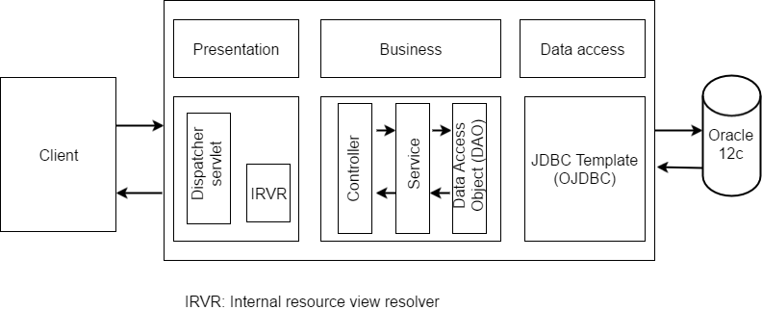

1. Java J2EE combined with Spring MVC design pattern is one of the better ways to come up with http REST coding. Some of the important features are as below

Dispatcher servlet - It is a design pattern that serves as the sole servlet implementation in servicing all the incoming http requests.

Internal resource view resolver – It’s a spring implementation which identifies the view example jsp, html etc. based on the http URL patterns.

1. Angular JS is a JavaScript based open source front end web application framework that supports MVC framework on the client side. Important feature of are as below

Decoupling of DOM elements from application logic.

Decoupling client side of an application from the server side.

1. Oracle 12c – Since, the application requires no compromise on consistency when it comes to CAP theorem and Oracle is one of the better DB in providing consistency. We have used Oracle 12c. Being the latest of the Database release from Oracle, this serves the purpose of data storage.